Ethem Özgüven

Fikir Öneş Sk 10/6, Gayrettepe, 34349 Beşiktaş / Istanbul / TK Tel: 0090-532-7916944
ethem.ozguven@bilgi.edu.tr
ethemozguven@gmail.com
www.ethemozguven.com

Education:

- PHD: Communication, Marmara University (2010)
- MA: Film and TV, Marmara University (1992)
- BA: Film and TV, Anatolian University (1986)

- AFS-scholarship Onteora Central Highschool, Woodstock, NY / USA (1977)

Teaching Experience

- Istanbul Bilgi University Communication Faculty (1999-)
- Marmara University, Fine Arts Faculty (1989-1991)
- Marmara University, Communication Faculty (1991-1992, 2006)
- Beykent University, Communication Faculty (1996-1998)
- Yıldız Technical University, Fine Arts Faculty (2004-2006)
- Europe Lefke University, Communication Faculty (Cyprus) (2005)

Courses:

- Documentary
- Contra
- Audio-visual Production
- C-Lab
- Final Thesis
- Practicum
- Experimental Video / Video Art

Other Work Experiences

- BIFED – Bozcaada International Festival of Ecological Documentary, coordinator (2014-)
- Environmental Script and Production Awards, 1997-1999
- Education modules for local Media makers – with special focus on women (2000 – 2005)
- FIMa – Association for Intercultural Media, 1992-2001
- (Creation of Workshop Modules for Video and Intercultural Education, 250 students from24 countries)
- Antalya Golden Orange International Short Film Festival, director, 1st international edition of the festival, 1995-1996

Articles

- Belgesel Sinemaya Dair Yazılar I: Belgesel ve Televizyonda Belgesel, Yeni Film, No: 18, 2009, pp 61-66
- Belgeselde Geçeklik ve Hakikat Tanımlama, Yeni Film, No: 19, 2010, pp 115-119
- Belgesel Sinemaya Dair Yazılar III: İyi Film Yapmak ya da Hangi Filmi Yapmak, Yeni Film, No: 19, 2010
- Belgesel Sinemaya Dair Yazılar IV: Festivaller ve Saptamalar, Yeni Film, No: 21, 2010, pp 71-76
- Belgesel Sinemaya Dair Yazılar V: Reklâm, Yeni Belgesel Formatı, Yeni Film, No: 23, 2011
- Belgesel Sinema Üzerine Yazılar VI: Kültürel Bellek, Yeni Film, No: 24, 2011
- CSLS (Contra Small Local Slow) Against Adverts, together with Petra Holzer, Interactions: Studies in Communication and Culture, Vol 5/3, 2014, pp 381

Web kontra

- 13 articles on Contra, https://kontraeng.wordpress.com/texts/

Conferences:

- Contra, “Vortex” at Ted^{x} Koç University, 2016
- CSLS (Contra Small Local Slow) Against Adverts, together with Petra Holzer, ‘Transforming Audiences, Transforming Societies’, Bahçeşehir University, COST, Istanbul , 2013
- Contra's, social projects on disabled, women and refugees, 4th European Communication Conference, ECREA, Istanbul, 2012
- Neo-Colonialization of “Non-Western” Documentary, Visible Evidence XVII, Istanbul, 2010
- The invisible (Görümeyenler), Keynote speaker at Cultural Studies Symposium, Karaelmas: Media and Culture, Zonguldak, 2009
- Contra, at Meetings of the South: Virtual vehicles and spaces, Videobrasil,
2007, http://site.videobrasil.org.br/festival/arquivo/festival/programa/1402398

Documentary

- Bad Seed, 46 min, 2018, HD
- The Touch, 53 min, 2016, HD mixed
- Commercial Break, 60 min, 2015, HD
- Black, 30 min, 2014, HD
- Sand, 41 min, 2011, DV cam
- Dust, 36 min, 2010, DV cam
- Silicosis, 49 min, 2009, DV cam
- 4857, 33 min, 2008, Mini dv
- Ata, Serçe and House, 26 min, 2008, Mini dv
- Mare Nostrum, 30 min, 2008, Mini dv
- Alethea, 41 min, 2007, Mini dv
- Tenedos, 10 min, 2005, Mini dv
- No, 54 min, 1997, Betacam
- Sipsi, 17 min, 1997, Betacam

- Fethi Kayaalp, 17 min, 2005, Mini dv
- TND, Mocumentary, 30 min, 2001, Mini dv
- Life Jackets Are Not Under Your Seats, 54 min, 2000, Mini dv
- The People of the Light’s Long Walk, 54 min, 2000, Mini dv
- The People of the Light, 60 min, 1998, Betacam
- Aziz Nesin, 26 min, 1994, Betacam
- Slave, 10 min, 1993, Betacam
- Dalyan, 26 min, 1993, Betacam

Contra / Campaigns

- Refugees
- Workers Without Social Security
- Sandblasted jeans / Silicosis
- Mediterranean
- Anti-smoking / Anti-drugs
- Ida
- Antipersonnel mines
- Violence against women
- Football and violence
- Earthquake in Van https://kontraeng.wordpress.com/contras/

Experimental Videos / Video Art / Short films

- Angst, Exp. Video, 2 min, 2016, HDcam
- Fallujah, Exp. Video, 5 min, 2005, Mini dv
- Delirium, Exp. Video, 6 min, 2005, Mini dv
- F, Exp. Video, 6 min, 2004, Mini dv
- Little Lake, Exp. Video, 4 min, 2003, Mini dv
- Erol Akyavaş, Exp. Video, 4 min, 2001, Mini dv
- AMN, Exp. Video, 3 min, 2001, Mini dv
- LIG, Exp. Video, 3 min, 2001, Mini dv
- LID, Exp. Video, 3 min, 2001, Mini dv
- İçbükey, Dance video, 6 min, 1999, Mini dv
- Transformaction, Dance video, 14 min, 1999, Mini dv
- LI-MO-NA-TA, Dance video, 16 min, 1998, Betacam
- İvme, Dance video, 7 min, 1997, Betacam
- Oromi, Dance video, 3 min, 1997, Betacam
- Su-Toprak, Exp. Video, 3 min, 1996, Hi8

- A, Exp. Video, 2 min, 1996, Hi8
- Ece, Video Art, 4 min, 1993, Hi8
- Ot, Short Film, 13 min, 1992, Hi8
- Ot 3, Exp. Video, 4 min, 1991, VHS
- Ot 1, Exp. Video, 5 min, 1990, V8
- İvme, Short film, 23 min, 1984, Umatic

Awards:

- Festival of Nations, Silver Bear, Austria, for “Ot”
- Interforum Film Festivals, Second Prize for Video Art, Germany, “Oromi”
- Henry Ford European Conservation Awards - Jury Special Award
- Cine 5 Jury Special Award, "Oromi"
- Retina International Documentary and Short Film Festival 3rd Award, Hungary, "The People of the Light"
- Marmara University National Documentary Festival, Jury Special Award, "The People of the Light"
- Bodrum International Environmental Film Festival, Jury Special Award, Documentary, "No"
- Ankara International Film Festival, Jury Special Award, Documentary, "Aziz Nesin"
- Ankara International Film Festival, Jury Award, Video Art, "ece"
- IFSAK Film, Best Documentary, "Aziz Nesin"
- IFSAK Film Festival, Best Video Art, "ece"
- IFSAK Film, Video Art Jury Special Award, "a"
- Ciné Med, Montpellier, France "Art School Student’s Award", "little lake"
- Environmental Film Festival Istanbul, 2nd Award for documentary, “Alethea”
- Bodrum International Film Festival, Environment Special Award, “kontra”
- Nürnberg Interforum, Mahmut Tali Öngören Human Rights Award, Germany, “4857”
- TRT International Documentary Film Festival, National Section 3rd Award, “Silicosis”
- Istanbul Architecture and Urban Films Festival, Best Documentary, “4857”
- Kadiköy Municipality and Lions Club Violence Against Children Film Competition, Best Film, “F1c”
- Mersin Chamber of Shipping Sea Short Film Competition, “Manyat”
- Journalists of Cinema Honor Award

Festivals (Official Selection)

- Oberhausen International Short Film Festival, Germany
- Festival dei Popoli, Florence, Italy
- Split International Video Art Festival, Croatia
- Mediaterra International Electronic Art Festival, Greece
- Munich International Documentary Film Festival, Germany
- Bucharest Dakino Film Festival, Romania
- Mediterranean Biennial de Aubagne, France
- FICA, International Environmental Film and Video Festival, Goias, Brazil

- Elche International Experimental and Dance Film Festival, Spain
- Mediawave International Short Film Festival, Györ, Hungary
- One World, Prague, Czech Republic
- International Short Film Festival Mons, Belgium
- International Short Film Festival Oberhausen, Germany
- Backup International New Media in Film Festival, Berlin, Germany
- Videoformes, Clermont Ferrand, France
- Exground, Germany
- Cinemambiente, Turin, Italy
- Curta Cinema, Rio de Janeiro, Brazil
- Malesacorto, Italy
- International Short & Independent Film Festival, Dhaka, Bangladesh
- Videoex International Video Festival, Switzerland
- Astra Film Festival, Romania
- Montevideo International Film Festival, Uruguay
- New European Cinema, Poland
- Planet in Focus, Toronto, Canada
- Adana Golden Boll Film Festival, Mediterranean Short Film Competition, Turkey
- Imaginario International Independent Film Festival, Italy
- Invideo Milano, Italy
- Festival de Cinema Bogota, Colombia
- Karafilm Festival, Karachi, Pakistan
- Cine Pobre, Cuba
- Next Festival, Lithonia
- Ecofilms, Rhodes International Films and Visual Arts Festival, Greece
- Cinema Verité International Documentary Film Festival, Tehran, Iran
- Videobrasil, Sao Paolo, Brazil
- Turkish Film Festival, Boston, USA
- Independent Short Film Festival, Santiago de Chile, Chile

Non-competitive Festivals and screenings

- International Video Festival, Bochum, Germany
- Documentarist, Turkey
- International Labor Film Festival, Turkey
- Laborfest, San Francisco, USA
- Lucania Film Festival, Italy
- Avicon Asia Video Art Conference, Tokyo, Japan
- Aluminum, Azerbaijan
- Transchina International Video Art Festival, China
- Thessaloniki International Dance Film Festival, Greece
- Samos Mediterranean Documentary Festival, Greece
- SEFORMA, Seoul Forum for Media Art, Korea

- New York Turkish Film Days, USA
- Rio Cinema London Film Festival, UK
- Tiflis Art Meeting, Georgia
- Signes de Nuit, Paris, France
- IMZ Dance Screen, Brighton, UK
- International Black Cinema, Berlin, Germany

Special Screenings / International Collections

- Videobrasil, “FF dossier”, editor: Eduardo de Jesus, http://site.videobrasil.org.br/dossier/dossier/542001
- Human Frames, Lowave, Curator: Silke Schmickl, Paris/Singapore, http://www.lowave.com/en/projects/865-human-frames-en
- Conditioned, a programme of video art from Turkey, Curator: Silke Schmickl, Paris/Singapore, http://www.lowave.com

Retrospectives

- Retrospective screening, METU, Ankara, 2004
- Retrospective, Kargaart, Istanbul, 2003
- Retrospective, Bosporus International Film Festival, 2014

Installations

- Nightmares, curator: Beral Madra, Goethe Institute Istanbul, 2000, (solo exhibition)
- Istanbulart, CRR Art Fair, 2000, “little lake”
- Selfportrait, curator: Beral Madra, Borusan Art Gallery, 2003, “TND”
- Missing? Karşı Sanat Çalışmaları, 2003
- Voices, 2003, Karşı Sanat Çalışmaları (Sound installation)
- The Thieving City, 2005, curator: Levent Çalıkoğlu, Aksanat. “Delirium”
- Copy, 2003, Mentalklinik, http://www.mentalklinik.com/exhibition/copy/#0
- Game, 2004, Mentalklinik
- Roll Magazine Exhibition at Istanbul Biennial, 2005
- Lowave at ARTIST, 2010
- Unexpected Territories, curator: Zeki Çoskun, ARTIST, 2016, “Souvenir”

Links to documentaries
The Touch, 53’, 2016 https://vimeo.com/164543536 PW: 2016thetouch
Alethea, 41’. 2007 / Ethem Özgüven, Petra Holzer http://www.cultureunplugged.com/documentary/watch-online/play/4451/Alethea Marenostrum, 30’, 2008, (trailer)
https://vimeo.com/60260556

Links to experimental video
a.m.n., 3’,2001
https://vimeo.com/984786 F, 6’, 2004,
https://vimeo.com/991381 Little Lake, 8’, 2003 https://vimeo.com/51223723 Angst, 2’, 2016
https://vimeo.com/192772209 PW: 2016angst

Links to Contra campaigns
This blog contains many of the campaigns, texts, videos. The texts are the philosophy of Contra
https://kontraeng.wordpress.com/ Violence & Football https://vimeo.com/2552696 https://vimeo.com/1018449

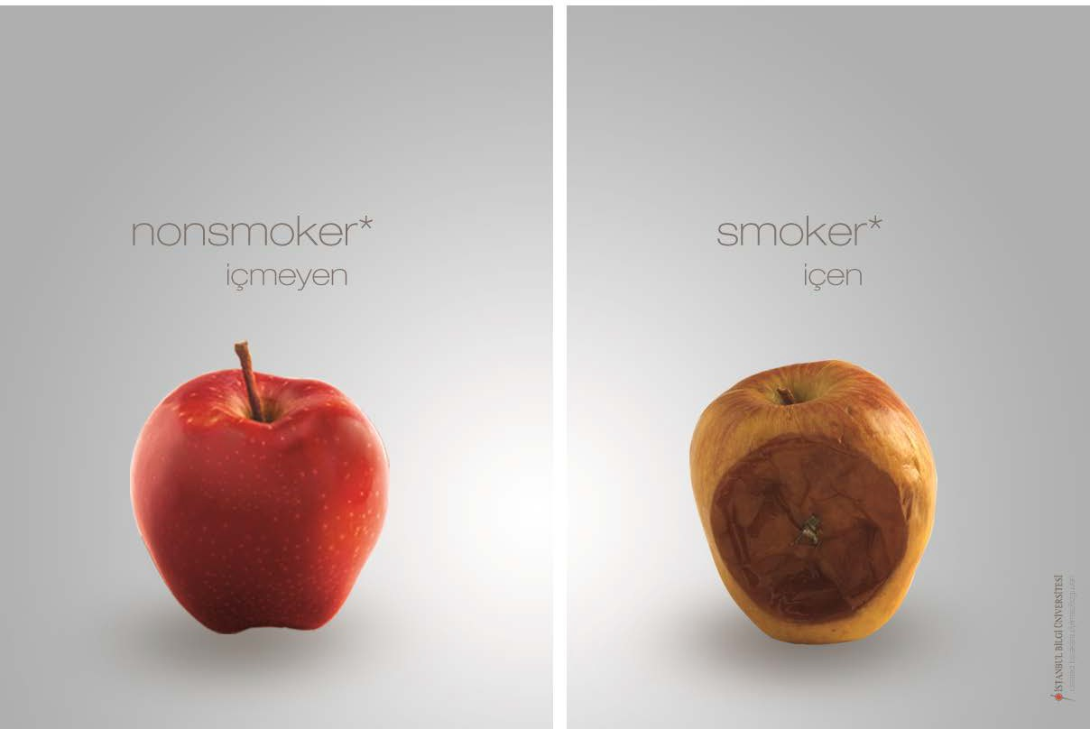

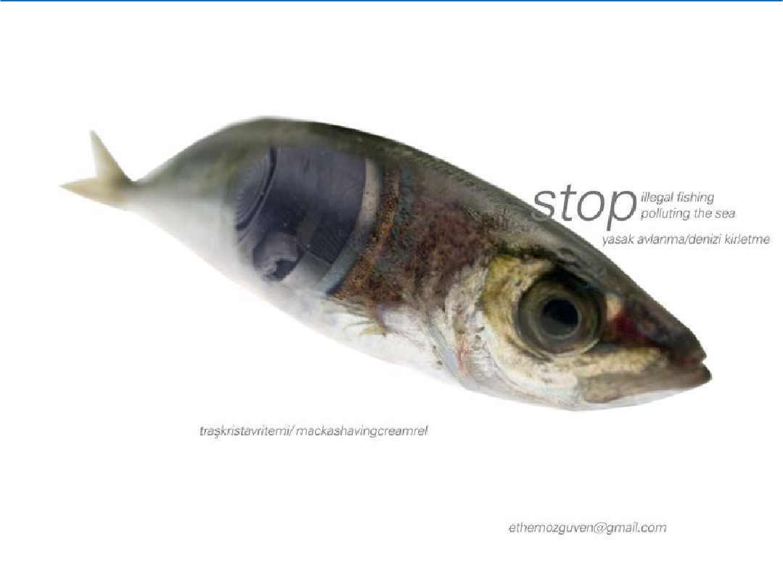

https://vimeo.com/1017665

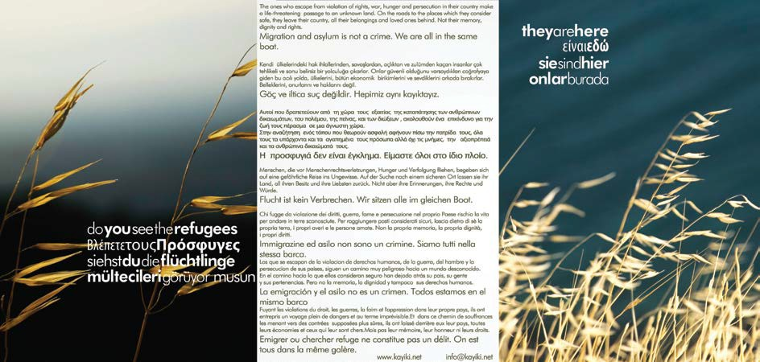

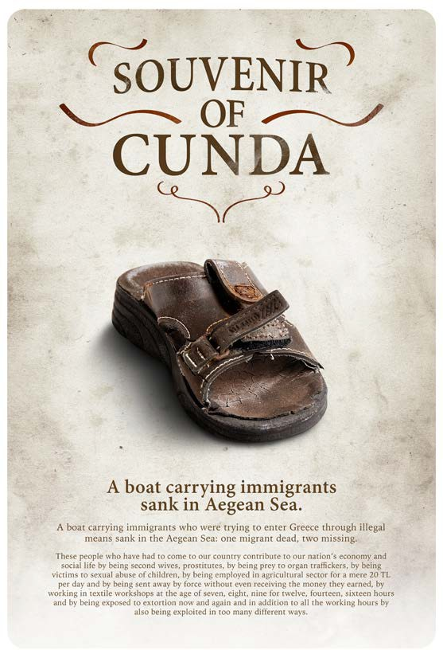

BIFED – International Festival of Ecological Documentary
http://www.bifed.org/en/
Member of GFN – Greenfilm Network http://greenfilmnet.org/
http://greenfilmnet.org/the-feeling-of-solidarity-against-all-odds/
http://greenfilmnet.org/the-festivals-of-green-film-network-recognize-and-support-bifed- from-every-country/

Links to artists, institutions and collobroators

Fatih Aydoğdu http://www.fazz3.net/ Alper Maral
Samples of compositions http://www.zapkolik.com/muzik/alper-maral Publication
http://www.sozcukitabevi.com/Kitap/techniques-of-20th-century-turkish-contemporary- music/alper-maral

Tolga Böyük
www.ffw.com.tr http://soundcloud.com/tolgabuyuk

Karşı Sanat Çalışmaları
http://www.karsi.com/etkinlikler_arsiv_en.php

Publications
CSLS (Contra Small Local Slow) Against Adverts, together with Petra Holzer, Interactions: Studies in Communication and Culture, Vol 5/3, 2014, pp 381
http://www.ingentaconnect.com/contentone/intellect/iscc/2014/00000005/00000003/art0 0009

